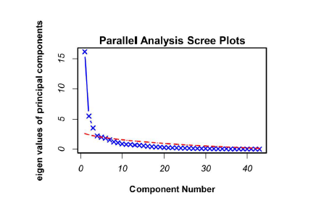
Fig. 1. Screen plot with parallel analysis for identifying the number of principal components to be kept. The blue cross indicates a principal component, and those above the red dashed line are candidate components.

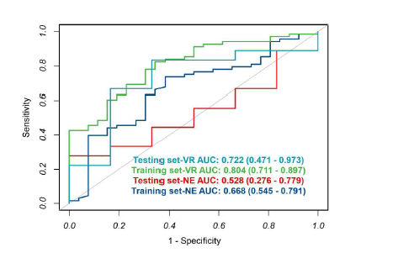
Fig. 2. The receiver operating characteristic curves of VR and NE derived from the training and validation set. VR, peritumoral edema/tumor volume ratio; NE, neutrophil.

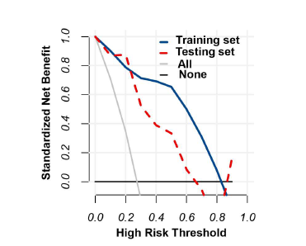
Fig. 3. Decision curve analysis of WT model for invasion diagnosis. For the training and validation sets the net benefit curve is shown. WT, whole tumor.

